Vending machine
By Matthew Monastrial CClvl4 Morning

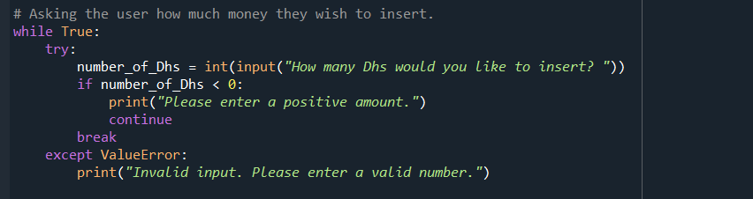
In here it shows how much money you can put and its unlimited, there is no limit for how much money you can put and of course you can put like 100 or 500. It depends on how many item is has

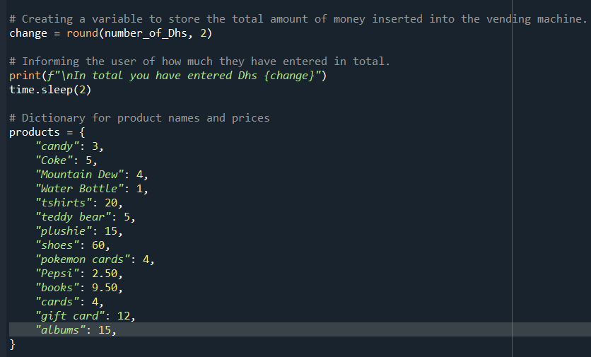
This shows the items that can be bought and you can buy as much as you want, you can just type the name of the item you want and it will show the item you picked.

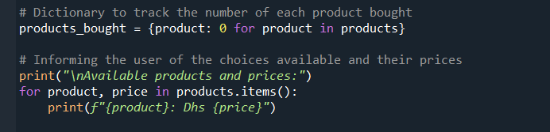
This tracks the remaining balance of the items of the vending machine and tracks each bought product, it also informs the user of the choices available plus the prices. The

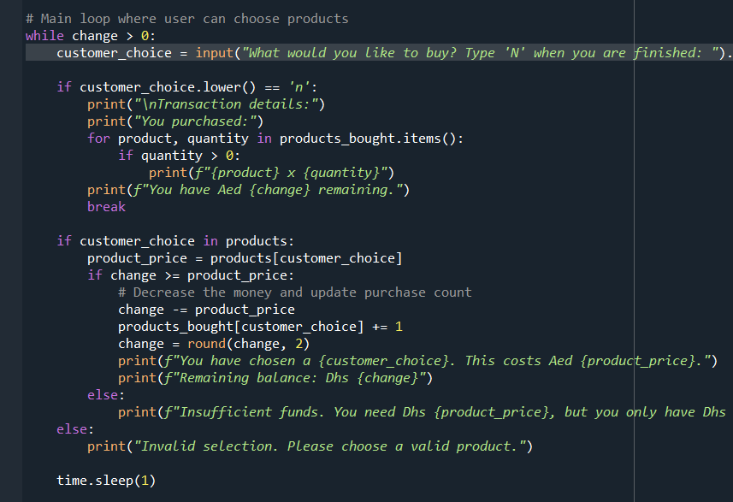
In here, you can type and buy the item you want and if your finished you type N to finish your shopping. If you put a little bit of balance and you bought too much, it will show insufficient funds because you only put a couple of balance in it, so if you don’t have anymore money, it will say insufficient funds and not let you buy anymore and you can just finish shopping.

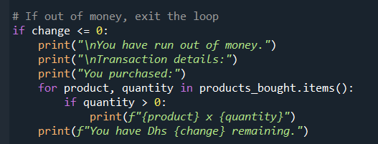
When you ran out of money, it shows that either you still have remaining balance or you don’t have any money left. You can put any product you want as long as you have enough balance.

